**IT314 – Software Engineering**



**Group 25**

**Diagnosis Expert System**

Table of content

Introduction: Design Document 2

Activity Diagram 2

Class Diagram 4

Sequence Diagram 5

Login 5

Diseases Diagnosis 6

Register as doctor 7

Register as patient 7

View report 7

# Introduction: Design Document

Here is the documentation of the Diseases Diagnosis expert system. With the activity diagram, class diagram of the system and its sequence diagram.

Activity Diagram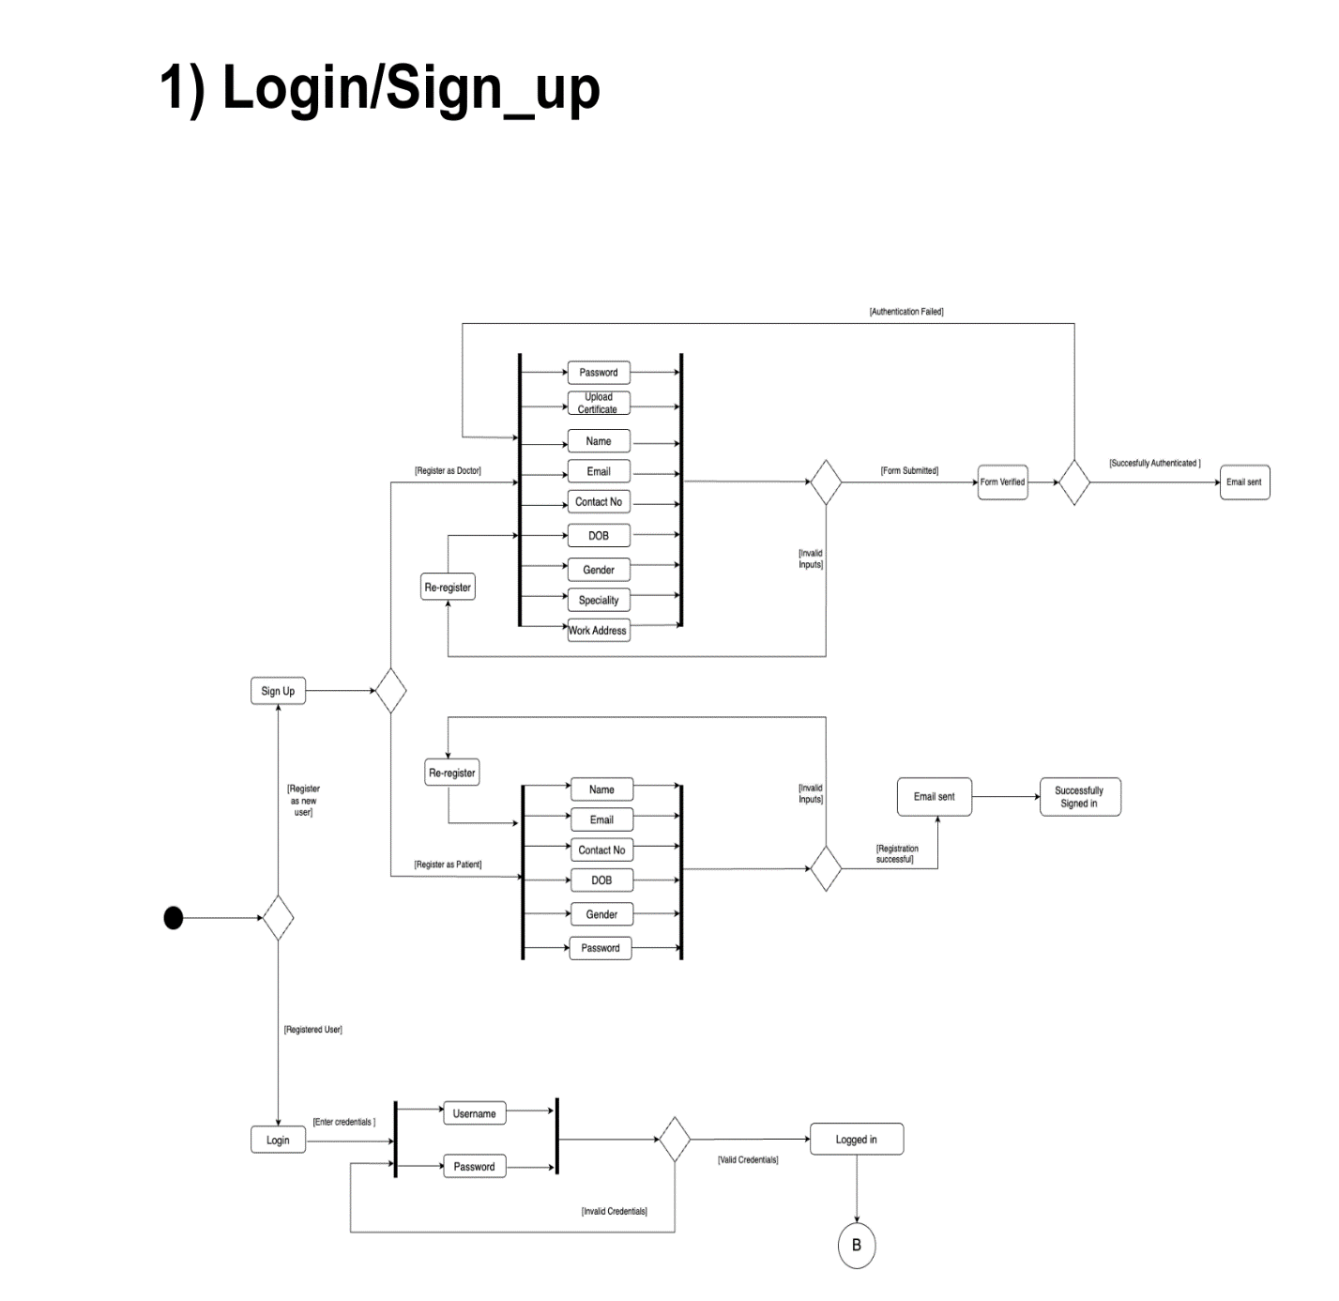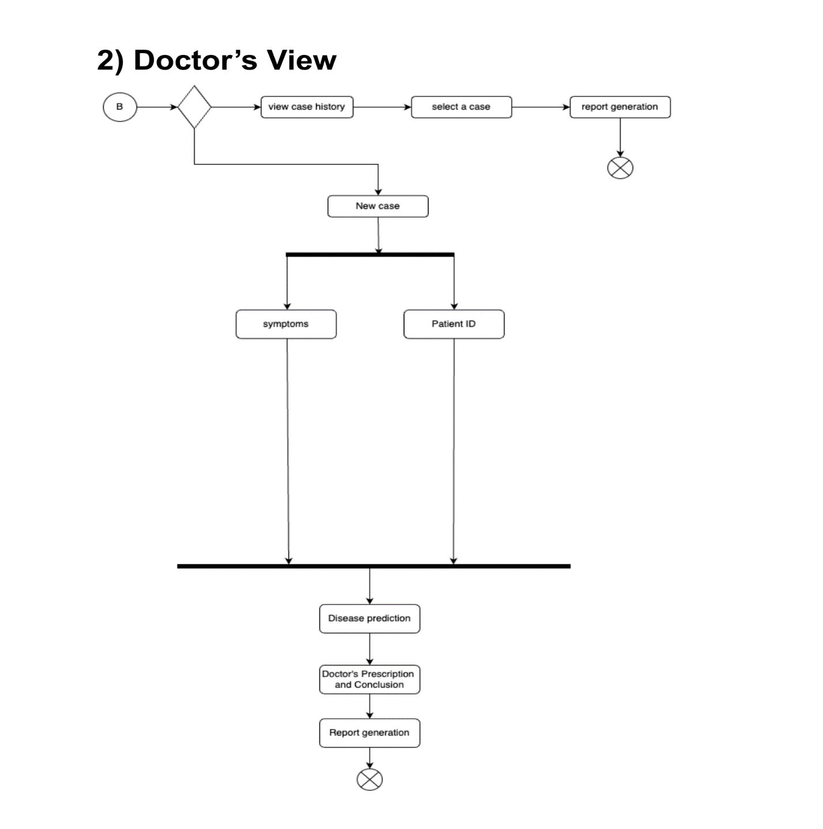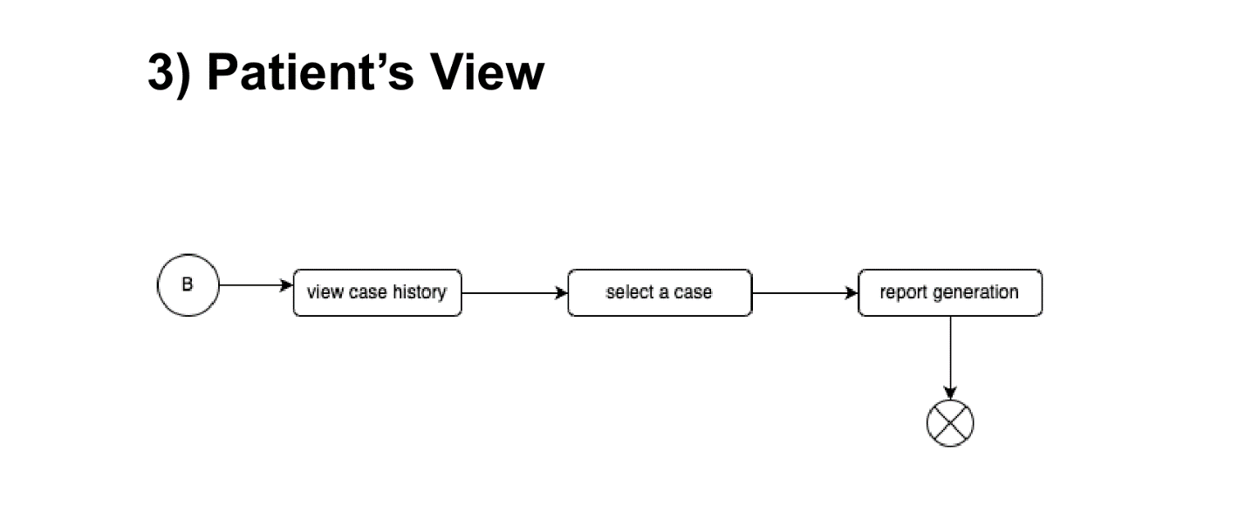

# Class Diagram

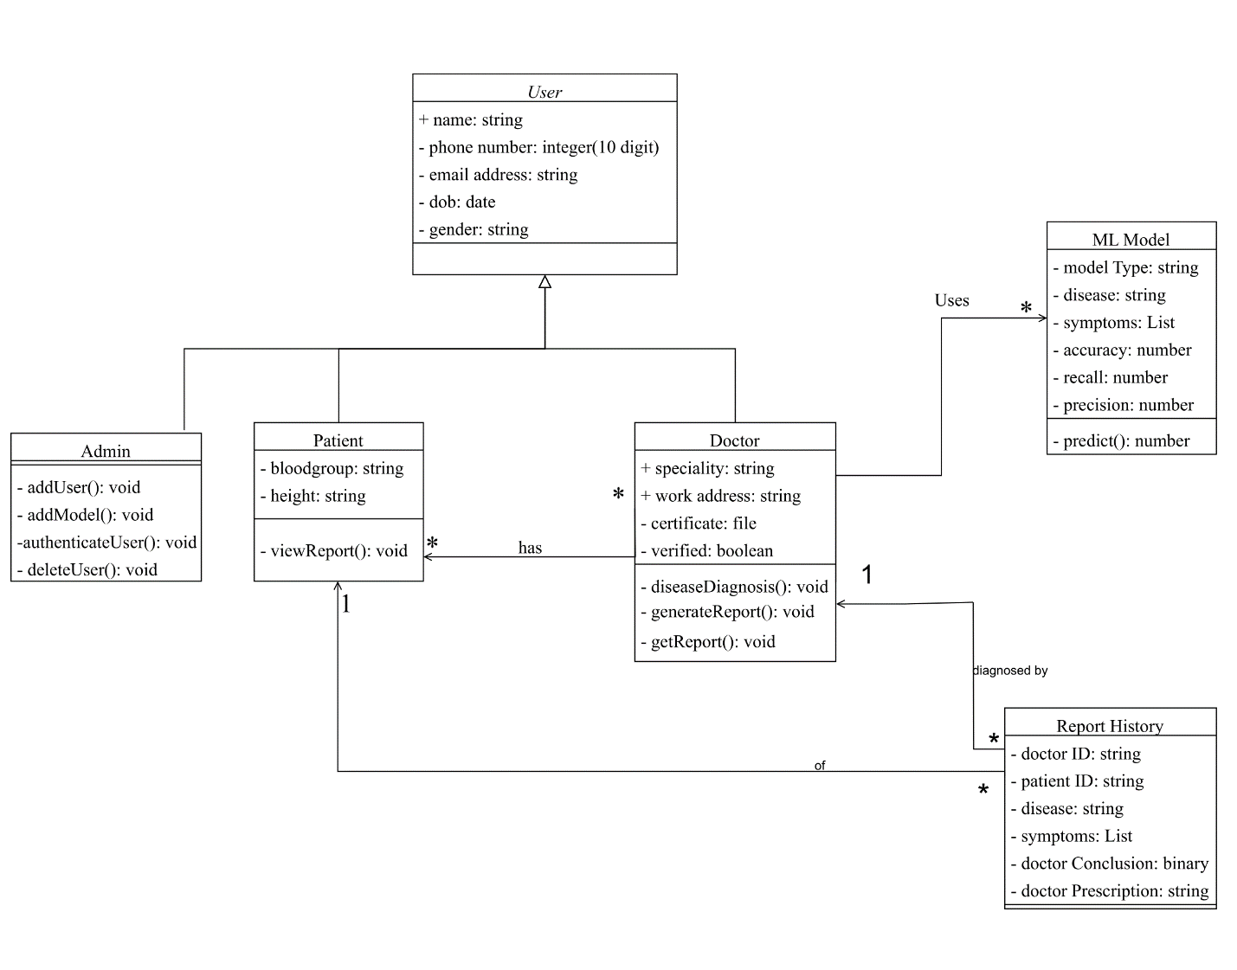

# Sequence Diagram

## Login

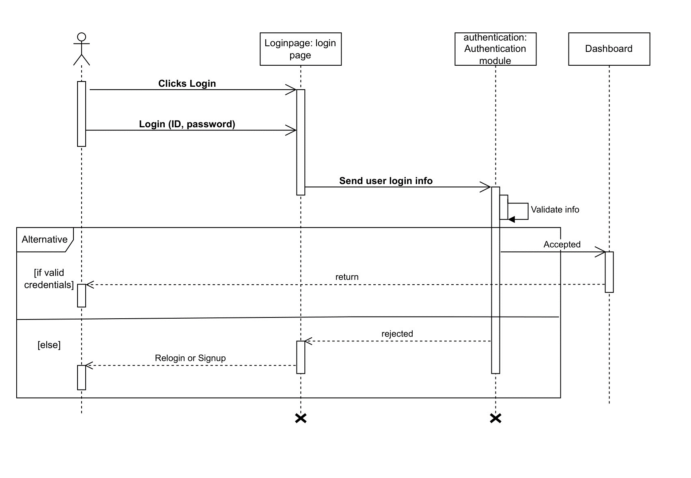

## Diseases Diagnosis

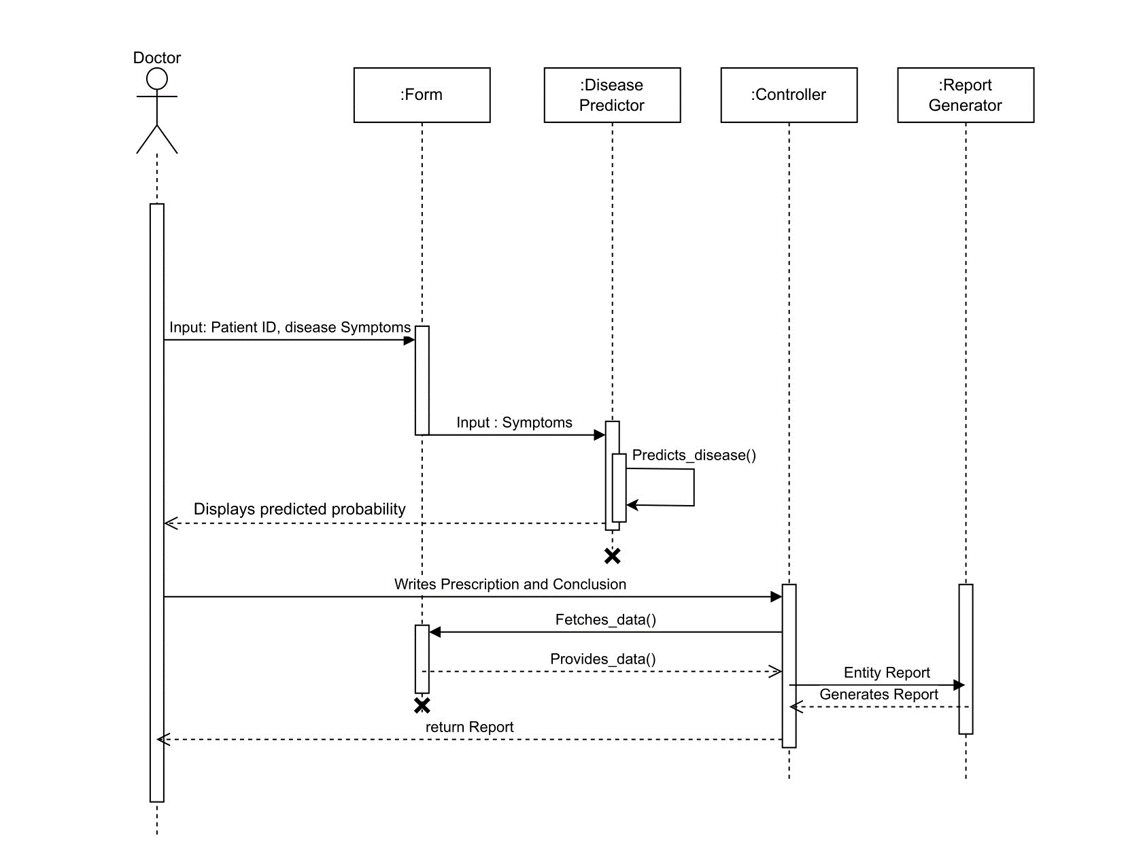

## Register as doctor

## Register as patient

## View report

